Social Story
  - Visiting Te Papa for Destination Mars

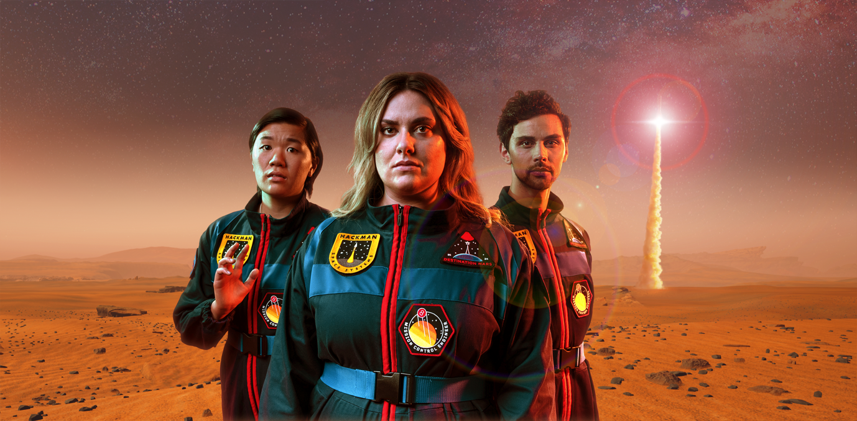

Introduction

Destination Mars is an immersive theatre performance. This means that action takes place all around you and you can choose to interact with the show or just watch.

It contains loud noises and fast-moving visual effects throughout the performance, in a similar way to watching a movie in a cinema.

It may not be suitable for those who experience sensory overload.

If we feel uncomfortable during the performance, we are welcome to leave at any point.

Venue

We are visiting Te Papa to see Destination Mars.

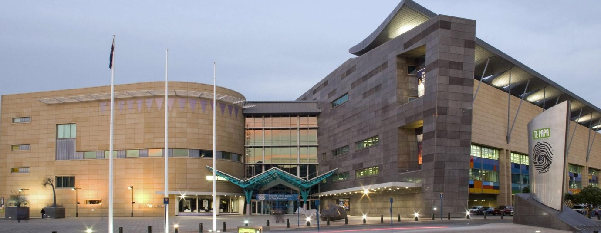

The performance is on the fourth floor of Te Papa. We will enter through the main entrance and use the elevator or the stairs to go to the fourth floor.

This is what the auditorium where the performance is looks like:

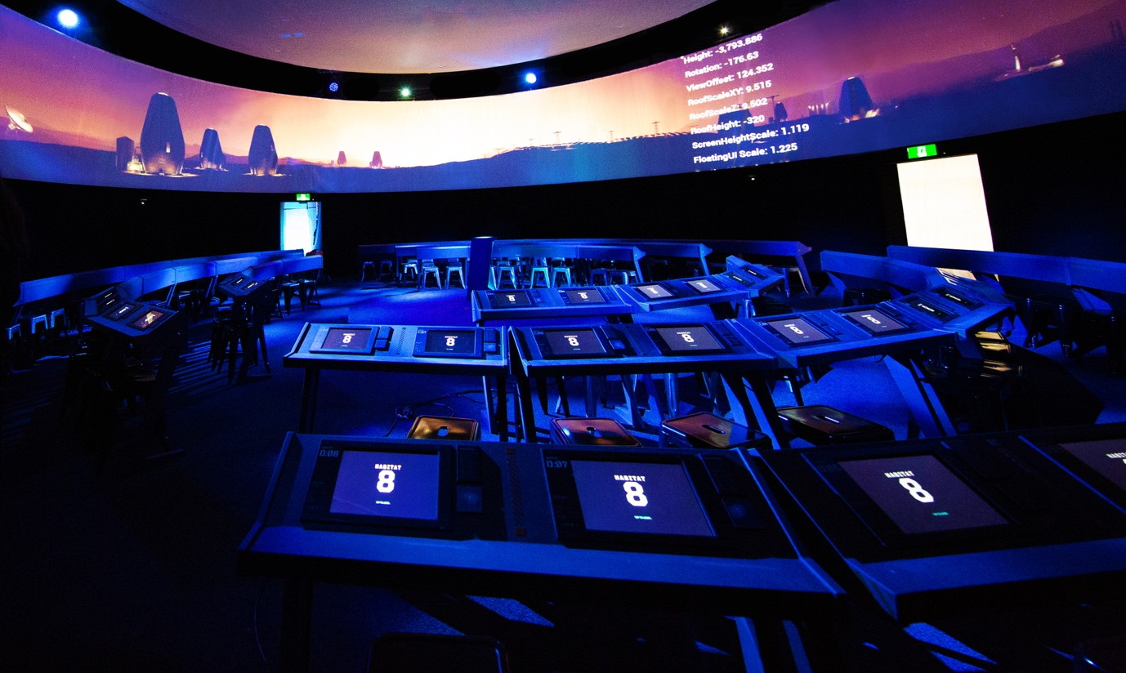

We will sit at a desk with digital tablets in front of us that we can use as part of the show.

If we just want to watch the show and not be involved in the audience participation, we will not enter our name and email address where asked on the tablet.

Performers

There are two actors in each performance of Destination Mars.

Two of these people will be in the performance we are watching:

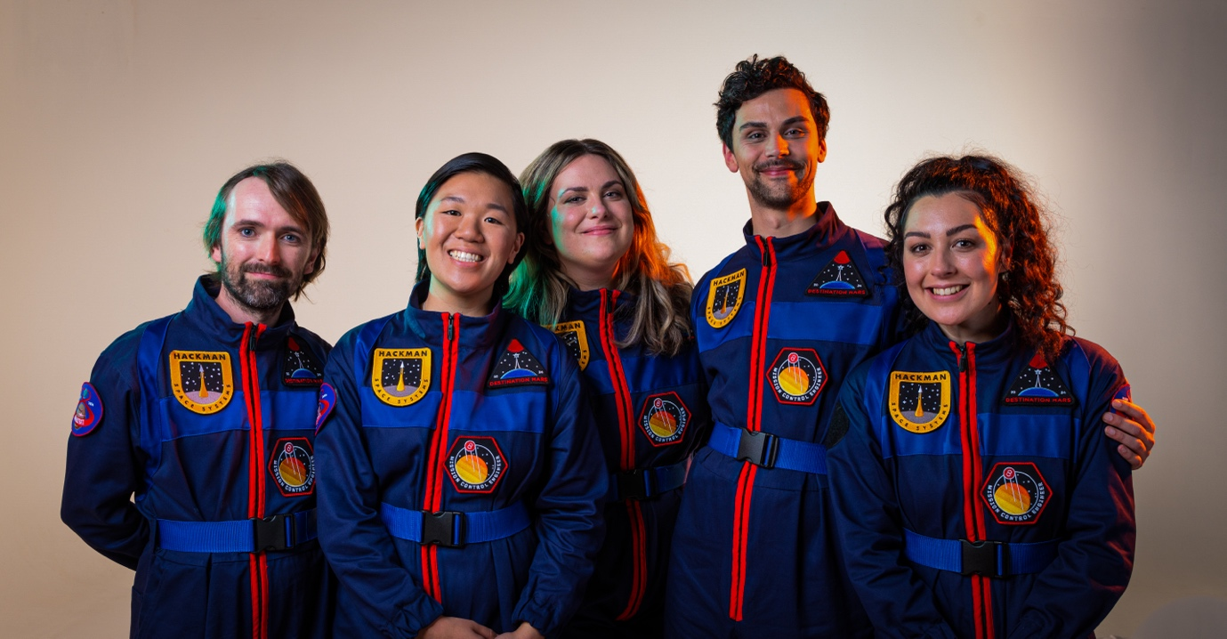

Their names in real life are, from left to right, Joel Baxendale, Isadora Lao, Hannah Kelly, Arlo Gibson and Emma Katene.

They will be wearing these costumes, which are astronaut uniforms.

If we want to know who will be acting in the performance we are watching, we can contact the Access Programme Producer at Aotearoa NZ Festival of the Arts to find out. His name is Nathan Mudge. His email is access@festival.nz and his phone number is 04 473 0149 ext. 6.

Show Summary

This summary contains spoilers.

It’s 2034, and we are on the planet Mars. We enter a dome-like environment, and are seated in a space station. We are engineers who use consoles to protect the base’s support systems and power up the next rocket launch.

We can choose not to actively participate in the show by not entering our name and e-mail address into our console when we are seated. If we do want to participate, we can enter our name and play games on our console while we wait for the show to start. We do not need to enter our e-mail if we do not want to.

Once everyone is seated, the Dome user interface (U.I.) begins to change. The dome clears and we see a countdown timer that is connected to a Voice Over, and a box with an arrow pointing towards where the sunrise will occur. The Voice Over and U.I. counts down from 5 to 1 and we see the sun cresting above the horizon. At this moment, the Dome’s U.I. changes again and it’s almost like a computer starting up. There are sounds, coding checks, testing icons and display changes. The Voice Over then gives some context around the world we are currently in.

The sounds change as though the broadcast has finished. The lighting and U.I.’s change and we find ourselves in the Control Room of a Martian settlement. The consoles also go back to their welcome screen.

We meet Ashley, our first character. Ashley will check in with different audience members about the information on their screens. We can say “I don’t know” if we don’t know the answer and it will not impact the show. Our second character, Dee Dee enters. She will be holding a tablet and will talk to Ashley and the audience. We are preparing to launch a rocket.

The Launch Control Mode Modal will appear on our screens. We will be given a passcode to enter into our console and it will display ‘Code Accepted’. The Console will then switch to launch control mode and display a job for each engineer/audience member to be in charge of for the launch. There is loud music and some shouting that fills this moment.

Next there will be a moment where Dee Dee goes through a checklist process and random audience members are asked to respond. If we are one of the random audience members our console will flash up with an instruction to say “GO”. It is OK to say GO either loudly or softly. It is OK not to respond and the show will continue. If it doesn’t come up on our screen, then we don’t need to say anything.

Then the screens will move into Flight Tracking with sound and lighting changes.

There is a countdown as we activate the launch sequence. Before the countdown reaches 0, there is a loud alarm and repetitive piercing sounds. The U.I. will show Warning Alerts.
There are Solar Flare modals on the consoles and the Voice Over tells us that a solar flare has been detected and will intercept with Mars in 91 seconds. An emergency siren kicks and music comes in to add a pulse to this action.

The consoles switch to System Shutdown and each audience member has to turn off a number of systems within the habitat. If we aren’t able to turn them all of in time, this will not affect the action of the show. The sounds and beats accompanying this will get louder and more urgent as we countdown again. Just as we are about to reach 0, Dee Dee shouts “Shut it down!”. The consoles go into U.V. mode and The Dome loses all its U.I. Everything will go dark and quiet.

Green, red and blue lights will dance across the roof of the Dome. It looks like the Northern lights. These illustrate solar wind and geomagnetic storms that are in the atmosphere, but it’s entirely safe. The music changes too and will be a lot softer.

Dee Dee and Ashley will the need our help to the reboot the system. It will sound like a 1990s computer linking to the early World Wide Web. Once completed, everyone gets the System Restart Screen and they press the ‘restart’ button and system reboots in Safe Mode theme. The Dome goes through a reboot too in ‘safe mode’ too which means we don’t see the projection of the outside of Mars. The Dome U.I. is simpler as well – looking like 1990s computer graphics.

Once restarted in Safe Mode, the screens change to Damage Assessment screens and the audience/engineers will need to complete some emergency tasks. The consoles have already been set up for individual audience members. Once we have read and checked the Damage Assessment, the screen is forwarded to the Primary Emergency Task. Each team has a mini game to complete that will take approximately 30 seconds, but it is ok if it takes us longer. Dee Dee and Ashley might help you if you need it, but the show will continue whether you complete the task or not.

An alarm will go off. Not as loud as before but definitely a warning signal. If we are sitting at the Transportation Systems consoles, a line will come up on the screen for us to read, “The Space Laboratory is going to crash!” If it doesn’t come up on our screen, then we don’t need to say anything. The Dome U.I. shows a graphical image of the Space Laboratory in the distance with flight tracking date alongside it, appearing to spin out of control. The Voice Over tells us, “Expected time of impact 6 minutes.” Dee Dee tells us that we need to launch a rocket into the Space Station to destroy it before it enters Mars’ atmosphere.

The Dome changes into Rocket mode. The Dome U.I. will show multiple rocket graphics as well as expected trajectories, including rockets exploding. The lights and music change into a tense feel and the audience have to work on a mini-game to redevelop the rocket to make it faster. Dee Dee and Ashley might help the audience with this and it will feel frantic. It is ok not to do the mini-game and the show will continue whether you complete the mini-game or not. One audience member will ‘win’ the mini-game and the rest of the screens will lock.

The sounds in the Dome change to rhythmic music and the consoles show an animation of a reboot into a normal theme and into Flight Tracking. The Dome U.I. graphics change again to show the launcher, and graphics and sound effects change to be more mechanical sounding. At 60 seconds, we start counting down and there will be more alarms. There will be a sound of sucking and then a mighty explosion – lift off. The Dome clears its U.I. so we can see the rocket launch into space. We will feel a rumble and see the rocket’s power. The Rocket impacts with the Space Laboratory and explodes. It’s like a giant firework in the sky.
We did it! Everyone is safe. Dee Dee asks the audience to give a round of applause for ourselves and everyone will clap. They may ask the audience to clap louder. Ashley will leave to start the clean-up of space junk that’s landed on Mars and Dee Dee tells everyone that it’s time to leave. The consoles will move to the ‘End of Show’ screen and Dee Dee will talk to members of the audience. We are allowed to take photos of Dee Dee if we want to before we leave.

Helpful People

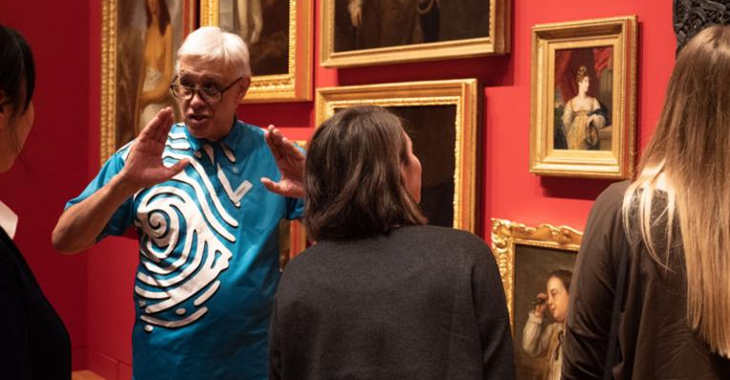
We will see a Te Papa host at the front desk.

We might see hosts in the Museum wearing blue Te Papa shirts.

If we have any questions about Te Papa, they can help us find the answer.

We can ask where to find the quiet or noisy spaces.

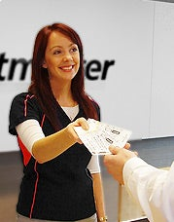

We will see Ticketmaster hosts before each performance at reception desks on floors 2 and 4.
We might see Ticketmaster hosts wearing black and red shirts.

If we have any questions about tickets, they can help us find the answer.

More Information

The staff at the front desk at Te Papa can provide earmuffs to reduce noise if it would make our visit easier.

For any more information about accessibility for Destination Mars and the Aotearoa New Zealand Festival of the Arts, we can contact:

Nathan Mudge
Access Programme Producer
access@festival.nz
04 473 0149 ext. 6

